

**KULLIYAH OF INFORMATION AND COMMUNICATION TECHNOLOGY**

**CSC 1706 PROBABILITY AND STATISTICS**

**SEMESTER 2, 2017/2018**

**SECTION 4**

**ASSIGNMENT: QUESTION 20**

**PREPARED BY:**

|  |  |
| --- | --- |
| **NAME** | **MATRIC NO.** |
| Ahmad Zaidan Bin Adnan | 1718733 |
| Muhammad Zaim Taqiyuddin Bin Zubir | 1714113 |
| Safiyyah Binti Ghazali Othman Taufik | 1718532 |
| Ahmad Zahin Fikri Bin Rozlee | 1713089 |
| Shafiq Azhar Bin Shahrizal | 1616313 |

**LECTURER**

DR. AFIDALINA TUMIAN

**DUE**

3 MARCH 2018

**QUESTION:**

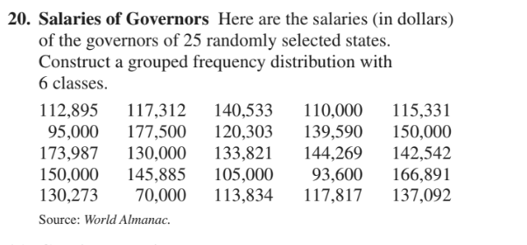

**HISTOGRAM**

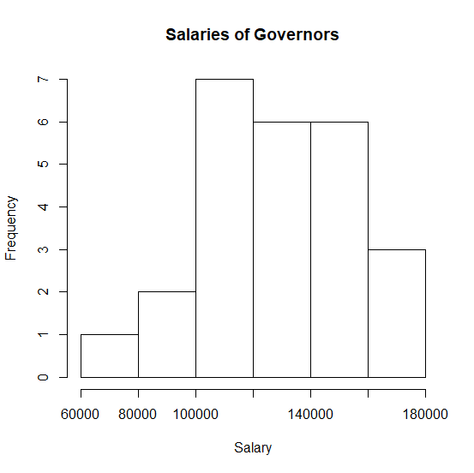

**CODES**

> data <- as.numeric(scan("SalaryGovernor.txt", what = "char"))

Read 25 items

> str(data)

num [1:25] 112895 117312 140533 110000 115331 ...

> range(data)

[1] 70000 177500

> min(data)

[1] 70000

> max(data)

[1] 177500

> data.freq <- table(data)

> percent.freq <- data.freq*100/sum(data.freq)

> data2 <- cbind(as.numeric(names(data.freq)), data.freq, percent.freq )

> colnames(data2)[1] <- "salary"

> write.table(data2, file = "updatedSalaryGovernor.txt", row.names = FALSE,quote = FALSE)

> breaks = seq(70000, 177500, by = width)

Error in seq.default(70000, 177500, by = width) :

object 'width' not found

> hist(SalaryGovernor.txt)

Error in hist(SalaryGovernor.txt) : object 'SalaryGovernor.txt' not found

> hist(data)

> hist(data, main="Salaries of Governors", xlab="Salary")

**FREQUENCY OF POLYGON**

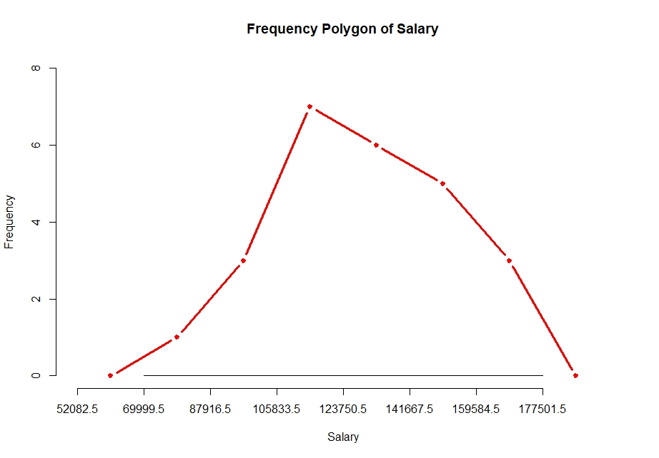

**CODES**

h <- hist(data, breaks = class.bound, xlim = c(class.bound[1]-width, class.bound[length(class.bound)]+width), ylim = c(0, 8), xlab =

"Salary", ylab= "Frequency", main = "Frequency Polygon of Salary", axes = F)

mp = c(min(h$mids) - (h$mids[2] - h$mids[1]), h$mids, max(h$mids) +

(h$mids[2] - h$mids[1]))

freq = c(0, h$counts, 0)

lines(mp, freq, type = "b", pch = 20, col = "red", lwd = 3)

axis(side=1, at =seq(class.bound[1]-width,

class.bound[length(class.bound)]+width, width),labels=seq(class.bound[1]-width, class.bound[length(class.bound)]+width, width))

axis(side=2, at =seq(0, 8, 2), labels=seq(0, 8, 2))